23.12: Get closest distance Energy conservation: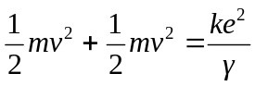
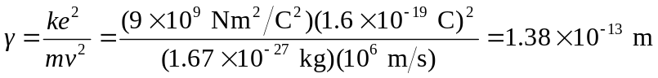
Maximum force:
